File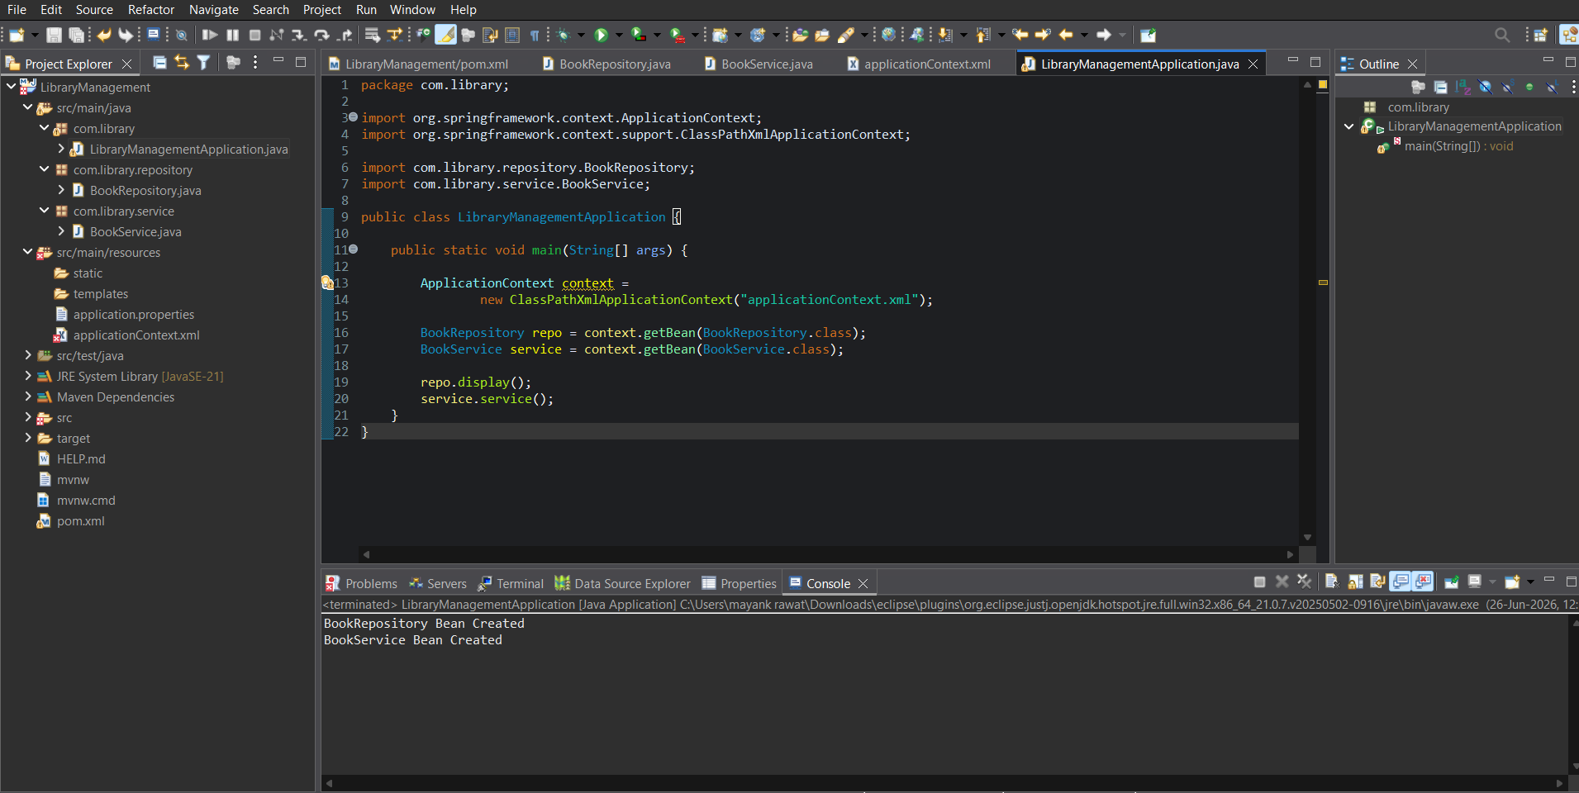

LibraryManagementApplication.java

package com.library;

import org.springframework.context.ApplicationContext;

import org.springframework.context.support.ClassPathXmlApplicationContext;

import com.library.repository.BookRepository;

import com.library.service.BookService;

public class LibraryManagementApplication {

 public static void main(String[] args) {

 ApplicationContext context =

 new ClassPathXmlApplicationContext("applicationContext.xml");

 BookRepository repo = context.getBean(BookRepository.class);

 BookService service = context.getBean(BookService.class);

 repo.display();

 service.service();

 }

}

BookRepository.java

package com.library.repository;

public class BookRepository {

 public void display() {

 System.out.println("BookRepository Bean Created");

 }

}

BookService.java
package com.library.service;

public class BookService {

 public void service() {

 System.out.println("BookService Bean Created");

 }

}


